**Application of Blockchain in Advanced Study Centre**

**Durgesh Rajdev Vishwakarma Dr. Hiren Dand**

**Abstract:**

Blockchain is the technology that can be used to create and manage secure, distributed ledger that can record transactions done between any two parties or individuals very efficiently, in a secure, verifiable and permanent way. Blockchain came into limelight in 2008 when Cryptocurrency Bitcoin was invented by Satoshi Nakamoto (or group of people). In modern world we are applying Blockchain in many fields such as Smart contracts, Healthcare, Real Estate, Cryptocurrency, and Education, Supply chain, Businesses and many other fields. This is all because of blockchain’s decentralization, immutable, secure and openness data storage structure.

In this research paper I will discuss about the application of Blockchain technology in Advanced Study Centre (ASC) system to enhance features.

**Keywords**: Blockchain; Educational System, Advance Study Centre, ASC, Educational Software.

1. **Introduction:**

Blockchain technology allow us to create a de-centralized environment, where transactions and data blocks are not under control of any third-party organization. The transaction completed between any two parties or individuals recorded in a block and then permanently stored in distributed public ledger, refer Figure 1 given below.

Blockchain technology uses three basic terminologies: Transaction, Block and Chain to provide transparent, decentralized, distributed and secure structure for data storage.

**Three basic terminologies in Blockchain technology:**

* **Transaction:**

The transaction is an operation of adding or removal of items from public ledger, which always leads to change in the structure and status of the ledger.

* **Block:**

The block stores result of all the transactions done between two parties or individuals in particular amount of time.

* **Chain:**

The chain is a chronological string of the blocks arranged by cryptographic method.

1. **The Blockchain technology can be implemented in following way:**

First, we need to create a distributed ledger in the network which only allows addition of new data in the distributed ledger i.e. data from ledger cannot be deleted, this will ensure the non-tamper ability of the data in ledger.

The blocks are interlinked into chain to form a chronological structure of string of blocks. Each block in structure stores the hash value of previous block, as shows in Figure 1. When anyone try to add new block of the transaction in the ledger then entire system will records the transaction and link it with the ledger. Meanwhile block is broadcasted over network and confirmed by all the nodes, which make block undeletable from ledger. In this way the data or block cannot be falsified or forged in system.

Therefore, the Blockchain technology has a transparent, decentralized, secure and distributed structure for data storage. After combining cryptographic technique with Blockchain, it guarantees that the data from ledger cannot be falsified or tamper, can be easily backtracked for transaction and data verification.

**Figure 1. Structure of Ledger in Blockchain**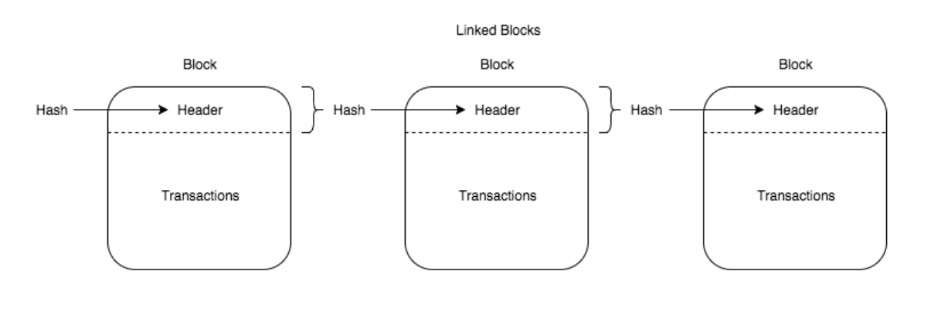

1. **Advance Study Centre (ASC):**

Advance Study Centre is an educational software, which is developed using conventional technologies such as PHP, JavaScript, MySQL and PostgreSQL. ASC system stores records in a central database located in the Linux server.

Refer Figure 2 for the context diagram of Advance Study Centre software.

In ASC or any educational system, we have some common fields such as Attendance, E-Learning, Results, Student Data Manage, Announcement and Financial records. We can apply Blockchain technology to enhance features of these fields to make educational software better.

Most of educational systems are still facing some common problems such as online record sharing, course creditability, student privacy, and course sharing. We can minimize these problems by combining Blockchain with educational system. In this paper I will discuss about this briefly. Also, we can add some new features in ASC system with more secure manner such as e-Certificates, e-Diploma, and online records and study material sharing.

Online sharing of academics certificates published by Blockchain technology allow everyone to verify certificates over web on trusted servers.

Use of Blockchain make these academics records non-tamper and unfalsified. We can even trace back from any point to verify any transaction performed on student’s educational, personal, attendance or financial records in ASC.

1. **Literature Survey:**

The literature research was done on seven different research papers and multiple websites given in reference section. The research string included different types of strings like “Application of Blockchain Technology”, “Online Education”, “Blockchain-based Educational Record Repository”, “Blockchain Opportunities and Challenges”, “Blockchain in Virtual Education” and “Exploring Blockchain technology and its potential applications for education”.

1. “Application of Blockchain Technology in Online Education” research paper presents the idea of Blockchain to enhance online exams which we can implement in ASC or any educations software.
2. “A Blockchain-based Educational Record Repository” research paper can be applied in ASC to store educational records more effective and secure way using Blockchain technology.
3. The Blockchain can be applied in ASC or any educational software to create and distribute digital certificates of students on web, which can be stored and verified easily at any point. This will help in reducing time for verification of academic certificates of students and provide trustworthiness.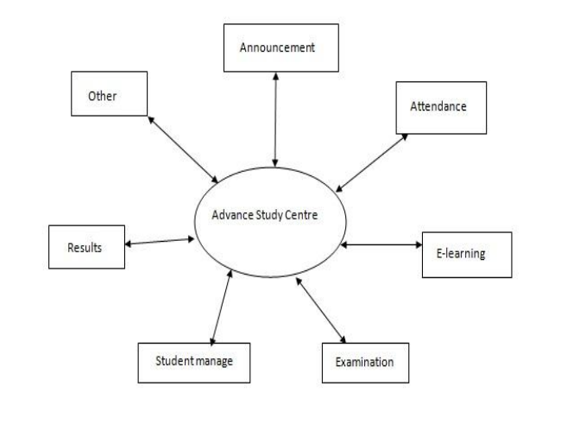
4. MIT has developed Blockchain based application that can issue and verify official records known as “Blockcerts Wallet”. This application allows creation of a certificate wallet for students. Students can get their e-certificates and e-diplomas instantly on their smartphones, laptops or any other internet connected smart device.
5. The University of Nicosia is the first higher educational institute that issues student’s academic certificates which can be verified through the Blockchain technology globally.
6. “Exploring Blockchain technology and its potential applications for education” research paper shows potential of the Blockchain technology has for educational system like ASC.

**Figure 2. Context Diagram of Advance Study Centre**

1. **Application of Blockchain in ASC:**
2. **Results**:

We can apply Blockchain technology in ASC to enhance results field. It will allow us to create and distribute academic results in trusted, secure, and open manner. These certificates will be stored with hashing algorithms present in Blockchain, which will make it non-tamper and highly secured.

1. **Attendance**:

We can also add Blockchain to manage attendance records of students in more efficient way. Attendance records of student can be stored in a block and then linked with previous blocks to form a distributed ledger, as shown in figure 1.

Distribution and non-tamper feature of Blockchain ensures that there is no falsified data present in attendance records in ASC database or ledger.

1. **Examination**:

Examination is the field where Blockchain can help a lot to manage data integrity. Examination data generate academic performance, certificate and results of students. Data in examination must be very secure and should not allow any modification without any prior reason. Blockchain allow us to back trace a block in distributed ledger from any for verification of data of any student to ensure data integrity and validate transactions performed on examination data stored in ASC.

1. **Financial Records**:

Blockchain is an accounting technology too. It is concerned with the transactions performed on financial records and maintain a ledger of accurate financial information. Blockchain has the potential to enhance the accounting profession by reducing the costs of maintaining and reconciling ledgers and providing absolute certainty over the ownership.

1. **E-Learning:**

In E-Leaning field, Blockchain can help ASC or any educational system to distribute learning material such as PDF, Documents, Files, Software, Videos, Links, etc. over web with data integrity and creditability of owner.

It will help students to get study material without any modification and credits to the owner of that study material.

1. **Distributed Storage**:

Currently ASC is storing data in a central PostgreSQL database. If someone successfully hacks central database of ASC, then he can alter actual data of ASC database easily. Data integrity will be lost here. We can minimize this problem by adding Blockchain technology in ASC.

Blockchain stores data in distributes and crypto-graphic manner. So, if someone want to hack data in ASC’s Blockchain ledger then he needs to hack and modify all the nodes in the ledger, which is near impossible, if we have secure and large number of nodes in ledger. This also avoid single-point-of-failure problem in central database of ASC too.

1. **Academic Record Verification**:

In K-12 and postsecondary verification of academic results, certificates and achievements remains largely a manual process i.e. heavy on paper documentation and checking case-by-case records. This problem can be easily resolved by Blockchain technology where anyone can verify academic documents easily on trusted sources. Records can be easily broadcasted across network, which will help employer & institutes to validate and verify records. It will help to globally recognize and verify records.

1. **Conclusion and Future work**:

In this paper I have proposed implementation of Blockchain technology in Advance Study Centre (ASC) to enhance features of an educational software. This can be also applied in other similar educational software like ASC to form a global Blockchain ledger with uniform data storage and verification structure.

Blockchain will ensure the security and integrity of data in ASC application. Also, it will reduce time for data verification and provide a uniform ledger where multiple colleges, institutes and universities can verify academic data of any student.

In terms of future work, we can evaluate the scalability issue and impacts associated with deployment of huge repository. The final aspect to be considered is to bring stockholders such as teachers, students, employees and contractors in a way that they can interact with each other on wide-spread and trustable network.

1. **References**:
2. “Application of Blockchain Technology in Online Education” by 1. Sun, Han 2. Wang, Xinge 3. Wang, Xiaoyue published on 15th September 2018.
3. “A Blockchain-based Educational Record Repository” by 1. Bessa, Emanuael 2. Martins, S. B. published on January 2019.
4. “The Blockchain and Kudos: A Distributed System for Educational Records, Reputation and Reward” by 1. Sharples, Mike 2. John published in year 2016.
5. “Exploring blockchain technology and its potential applications for education” by 1. Guang Chen 2. Bing Xu, 3. Manli Lu 4. Nian-Shing Chen published on 03 January 2018.
6. “Blockchain in Education” by Anthony Camilleri published in December 2017.
7. “Blockchain Technology and its Applications for Virtual Education” by 1. [Mavaluru](https://www.researchgate.net/scientific-contributions/2010730680_Dinesh_Mavaluru), Dinesh 2. [Arishi](https://www.researchgate.net/profile/Hamzah_Arishi2), Hamzah 3. [Ra](https://www.researchgate.net/profile/Mythily_Ra), Mythily published in October 2018.
8. “Understanding Blockchain Opportunities and Challenges” by Holotescu, Carmen published in April 2018.
9. https://en.wikipedia.org/wiki/Blockcain
10. https://www.forbes.com
11. https://dataconomy.com/2019/01/how-will-blockchain-transform-the-education-system/
12. <https://www.bacancytechnology.com/blog/blockchain-in-education-sector/amp/>
13. <https://www.researchgate.net/>
14. <http://www.vpmthane.org/adc/index.htm>